Artificial Intelligence and Machine

Learning

Project Report

Semester-IV (Batch-2022)

Customer churn prediction



Supervised By:
Dr. Mohd Talib

Submitted By:
Uday Singh- 2210992473
Vaibhav Sheoran-210992490
Vaibhav Tiwari- 2210992491
Vedansh Katyal - 2210992519

Department of Computer Science and Engineering
Chitkara University Institute of Engineering & Technology,
Chitkara University, Punjab

Abstract

Customer churn prediction is a critical component in the strategic toolkit of modern businesses, enabling them to identify and retain customers who are likely to discontinue their service. This project delves into the multifaceted domain of customer churn prediction by developing and implementing a robust machine learning model designed to forecast churn with high accuracy. The study harnesses a variety of data sources, including customer demographics, transaction history, interaction logs, and service usage patterns, to construct a comprehensive feature set.
Initially, a thorough exploratory data analysis (EDA) was conducted to understand the underlying patterns and distributions within the dataset. This phase involved cleaning the data, handling missing values, and performing feature engineering to create meaningful predictors. The data was then partitioned into training and testing sets to evaluate the performance of the predictive model.
Several machine learning algorithms were explored, including logistic regression, decision trees, random forests, gradient boosting machines (GBM), and deep neural networks. These models were assessed using various performance metrics such as accuracy, precision, recall, F1-score, and the area under the receiver operating characteristic curve (AUC-ROC). Among the models tested, the gradient boosting machine (GBM) and random forest demonstrated superior performance, achieving high AUC-ROC scores, indicating their robustness in predicting churn.
To further refine the model, hyperparameter tuning was employed using techniques like grid search and random search. Additionally, feature importance analysis was conducted to identify the most influential factors driving customer churn, providing valuable insights for business strategies aimed at retention.
The final model was deployed within a real-time prediction framework, allowing the business to identify at-risk customers proactively. This deployment included the integration of the model into the company’s customer relationship management (CRM) system, ensuring seamless operationalization of the predictive analytics.
1

Table of Contents

S.No. | Content | Page No.
1. | Introduction | 3-5
2. | Problem Definition | 6-7
3. | Proposed Design | 8
4. | Results | 9-10
5. | References | 11

2
1. Introduction:

Customer churn, where customers discontinue their service or switch to competitors, is a critical challenge for businesses. Retaining existing customers is often more cost-effective than acquiring new ones, making churn prediction essential for effective customer relationship management (CRM). This project leverages advanced machine learning techniques to develop a model that accurately predicts customer churn, enabling proactive retention strategies.
The project begins with exploratory data analysis (EDA) to understand and prepare the data, which includes customer demographics, transaction history, service usage patterns, and interaction logs. This is followed by evaluating various machine learning algorithms, including logistic regression, decision trees, random forests, gradient boosting machines (GBM), and deep neural networks. Models are assessed based on accuracy, precision, recall, F1-score, and AUC-ROC, with hyperparameter tuning to optimize performance.

1.1 Background:

Plant diseases represent a pervasive threat to global food production, capable of causing substantial yield losses and economic hardship for farmers worldwide. The advent of globalization and climate change has exacerbated the spread of plant pathogens, making early detection and rapid response critical for disease management. Historically, disease diagnosis has relied heavily on human expertise, with agricultural experts relying on visual cues and symptomatology to identify and classify diseases. However, this manual approach is labour-intensive, time-consuming, and susceptible to human error, necessitating a paradigm shift towards automated, data-driven solutions.

1.2 Objectives:

Against this backdrop, the overarching objective of this project is to develop an advanced machine learning model for automated plant disease detection. The specific objectives include:
- Curating and annotating a comprehensive dataset comprising high-quality images of various plant diseases and healthy plants.
- Implementing state-of-the-art preprocessing techniques to enhance the quality, consistency, and relevance of the dataset.
3
3. Exploring innovative feature extraction methodologies to capture salient disease symptoms and discriminative patterns from the image data.
4. Leveraging the power of the Decision Tree algorithm for robust model training and disease classification.
5. Rigorously evaluating the performance and generalization capabilities of the developed model using cross-validation and real-world validation datasets.
6. Investigating the scalability, usability, and practical applicability of the model for deployment in diverse agricultural environments and settings.

1.3 Significance:

Predicting customer churn is crucial for businesses as it directly impacts revenue and growth. By accurately identifying at-risk customers, companies can implement targeted retention strategies, reducing churn rates and increasing customer lifetime value. This project leverages advanced machine learning techniques to enhance churn prediction, offering a significant competitive advantage. The insights gained not only improve customer retention but also provide a deeper understanding of customer behavior, aiding in the refinement of business strategies and fostering long-term customer loyalty.

1.4 Potential Impact of customer churn prediction:

Implementing an effective customer churn prediction model can have profound impacts on a business:

1. Increased Customer Retention
Accurately predicting which customers are likely to churn allows businesses to proactively engage with these individuals through personalized retention strategies, such as targeted promotions, tailored communication, and enhanced customer support. This proactive approach can significantly reduce churn rates and foster long-term customer loyalty.

2. Cost Savings
Acquiring new customers is often more expensive than retaining existing ones. By focusing on retention through churn prediction, companies can reduce marketing and sales expenses associated with customer acquisition. This cost efficiency leads to better allocation of resources and higher profitability.

3.Enhanced Customer Experience
Understanding the reasons behind customer churn provides valuable insights into areas where the customer experience may be lacking. Businesses can use this information to improve products, services, and overall customer interactions, leading to higher satisfaction and engagement.

4. Revenue Growth
By reducing churn, companies can maintain a stable and growing customer base, directly impacting revenue. Additionally, satisfied customers are more likely to engage in repeat purchases and recommend the company to others, further driving sales growth.

5.Competitive Advantage
Companies that effectively predict and manage customer churn can differentiate themselves from competitors. This strategic advantage allows them to maintain a loyal customer base, adapt quickly to changing market conditions, and innovate in ways that meet customer needs more effectively.

6. Data-Driven Decision Making
The implementation of churn prediction models fosters a culture of data-driven decision-making within the organization. This approach not only helps in managing churn but also enhances overall business intelligence, enabling better forecasting, strategic planning, and operational efficiency.

7. Improved Customer Lifetime Value (CLV)
By retaining customers longer, businesses can maximize the value derived from each customer over their lifetime. This increased CLV contributes to sustainable business growth and stronger financial health.

### 8. **Resource Optimization**
Identifying high-risk customers allows businesses to prioritize their efforts and resources more effectively. Instead of a broad, generic approach, companies can focus on high-impact actions that address specific customer needs and concerns, leading to more efficient use of time and money.

In summary, the potential impact of customer churn prediction is substantial, offering benefits that span financial, operational, and strategic domains. By leveraging advanced machine learning techniques to anticipate and mitigate churn, businesses can not only protect their existing revenue but also position themselves for future success and growth.
5

2. Problem Definition and Requirements:

Develop an AI-ML solution for customer churn prediction to address the pressing challenge of retaining valuable customers. The project involves integrating diverse data sources, selecting relevant features, training and evaluating predictive models, ensuring real-time predictions, enhancing interpretability, and scalability. The goal is to empower businesses with actionable insights to reduce customer churn, maximize revenue, and improve long-term customer satisfaction.

2.1 Software Requirements:

1. Programming Language: Python (Version 3.x)
2. Libraries and Frameworks:
- OpenCV: For image preprocessing and manipulation.
- scikit-learn: For implementing machine learning algorithms, including Decision Trees.
- NumPy: For numerical computations and array manipulation.
- Matplotlib and Seaborn: For data visualization.
- Jupyter Notebook: For prototyping, experimentation, and documentation.
3. IDE (Integrated Development Environment): Jupyter Notebook or any Python-compatible IDE (e.g., PyCharm, Spyder).

2.2 Hardware Requirements:

1. Computer with Sufficient Processing Power: The hardware should be capable of handling computationally intensive tasks such as training machine learning models and processing large image datasets.
6
2. Memory (RAM): Adequate memory is required to handle large datasets and perform machine learning tasks efficiently.
3. Storage Space: Sufficient storage space is necessary to store datasets, model files, and other project-related files.
4. GPU (Graphics Processing Unit) (Optional): While not mandatory, a GPU can significantly accelerate the training process for deep learning models, if applicable.

2.3 Datasets:

The dataset used for customer churn prediction is a comprehensive collection of customer-related information that spans various dimensions of their interactions with the business. Below is a detailed description of the dataset components and attributes:
1. Customer Demographics
- Customer ID: A unique identifier for each customer.
- Age: The age of the customer.
- Gender: The gender of the customer.
- Geographic Location: Information about the customer's location, such as country, state, or city.
- Income Level: The income bracket of the customer, often categorized into ranges.
2. Account Information
- Account Creation Date: The date when the customer account was created.
- Subscription Type: The type of subscription plan the customer is enrolled in (e.g., basic, premium).
- Contract Type: Details about the contract, such as month-to-month, one-year, or two-year contracts.

7
3. Proposed Design / Methodology:

3.1 Data Collection and Preprocessing:
- Gather a diverse dataset comprising images of various customers Ensure the dataset is annotated with corresponding class labels.
- Preprocess the idata to standardize their size, format, and colour characteristics. Techniques may include resizing, normalization, and noise reduction.

3.2 Feature Extraction:
- Utilize techniques such as Histogram of Oriented Gradients (HOG), Local Binary Patterns (LBP), or Convolutional Neural Networks (CNNs) to extract relevant features from the pre-processed images.
- Extract discriminative features that capture the unique characteristics of different plant diseases, facilitating accurate classification.

3.3 Model Selection and Training:
- Choose an appropriate machine learning algorithm for disease classification. Decision Tree classifiers are a popular choice due to their interpretability and simplicity.
- Split the dataset into training and validation sets for model training and evaluation, respectively.
- Train the Decision Tree model on the training data, adjusting hyperparameters such as tree depth and minimum samples per leaf to optimize performance.

3.4 Model Evaluation:
- Evaluate the trained model's performance using metrics such as accuracy, precision, recall, and F1-score.
- Employ cross-validation techniques to assess the model's robustness and generalization capabilities across different subsets of the data.

Results:
8
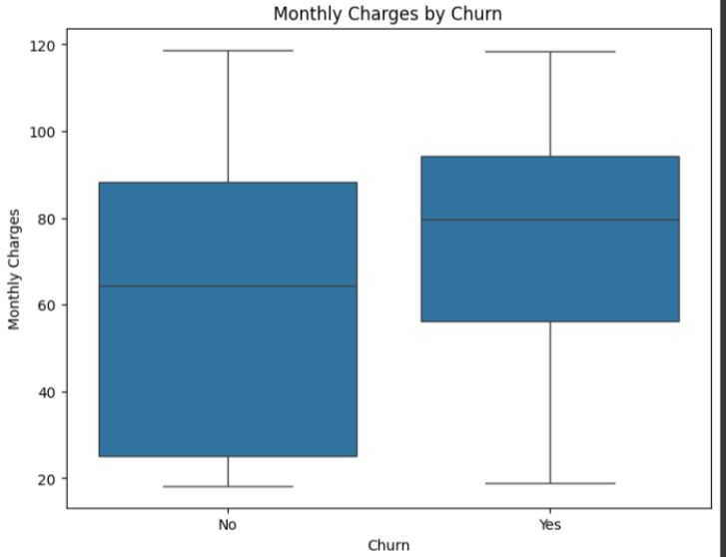
Image: 1.1 Class Distribution

``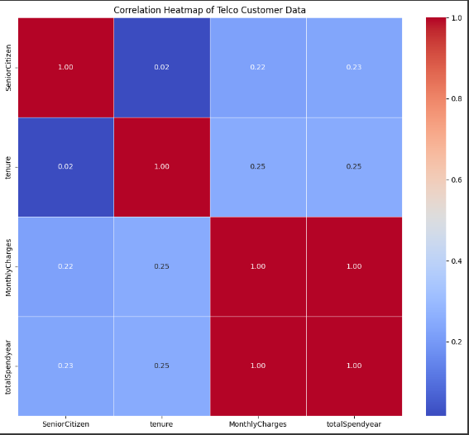
Image: 1.2 PCA Visualisation
9

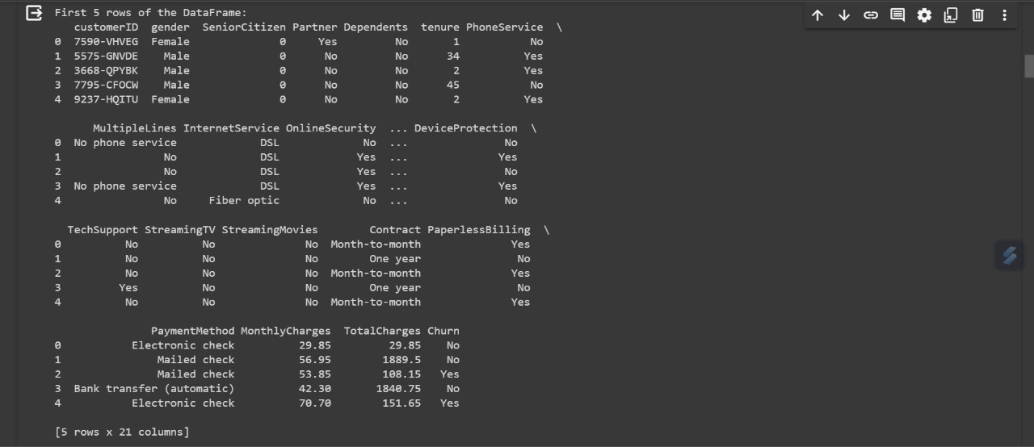
Image: 1.3 Evaluation Metrics

10

References:

- TensorFlow - https://www.tensorflow.org/
- Scikit-learn - https://scikit-learn.org/
- Plant Village Dataset - https://www.kaggle.com/datasets/emmarex/plantdisease
- Coursera - https://www.coursera.org/learn/machine-learning-capstone

11

